iPerform Theatre Company presents....

Smoggle, Puff, and Rognarok: The quest to slay a dragon

Smoggle, Puff, and Rognarok: The quest to slay a dragon

iPerform Theatre Company presents....

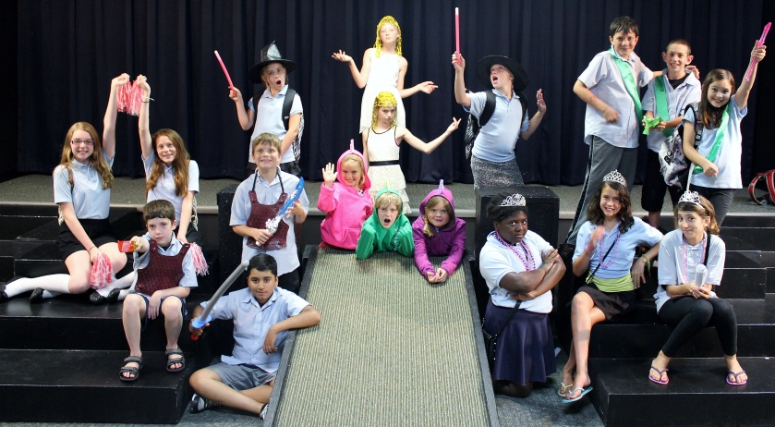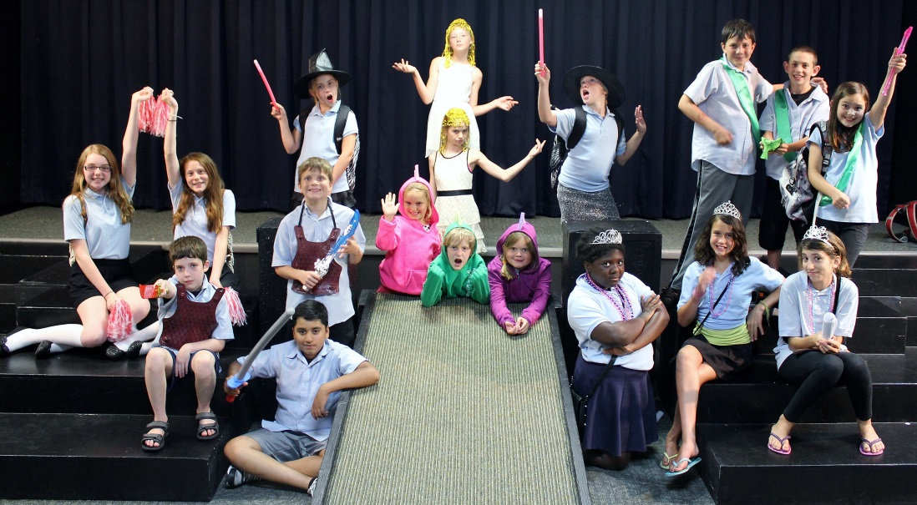 





**Where:** Maternity of Mary-Saint Andrews School (592 Arlington Avenue W)

**When:** August 4th at 7:00 p.m.

**Admission:** $8 for adults, $5 for kids

**Where:** Maternity of Mary-Saint Andrews School (592 Arlington Avenue W)

**When:** August 4th at 7:00 p.m.

**Admission:** $8 for adults, $5 for kids

Written by: Zach Schroeder Directed by: Cristina Corrie and Molly Raths Performed by: Como Park Youth

Written by: Zach Schroeder Directed by: Cristina Corrie and Molly Raths Performed by: Como Park Youth